Multi Camera mount (3 cameras 1 Clamp)

Back Side camera bracket
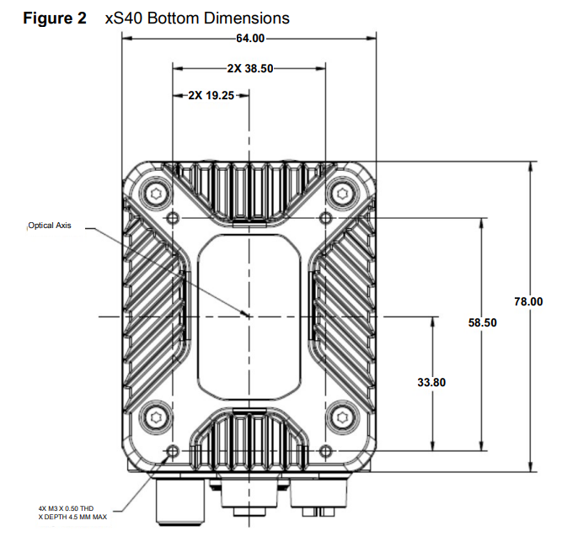

Mounting screws
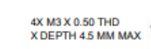
I set the thickness to 4 mm so I can use M3 x 8 mm and a washer.
→

Multi Camera mount 2.0 (3 cameras 1 Clamp)
Improvements:
- Better alignment of the beam and the mounting plate
- Rounded mounting plates (10 mm radius)

Camera Plate
I add 4 R10 circles to round the plate and make it smooth
Changed the side mounting holes with a 16 mm rounded flange to better adapt to the beam
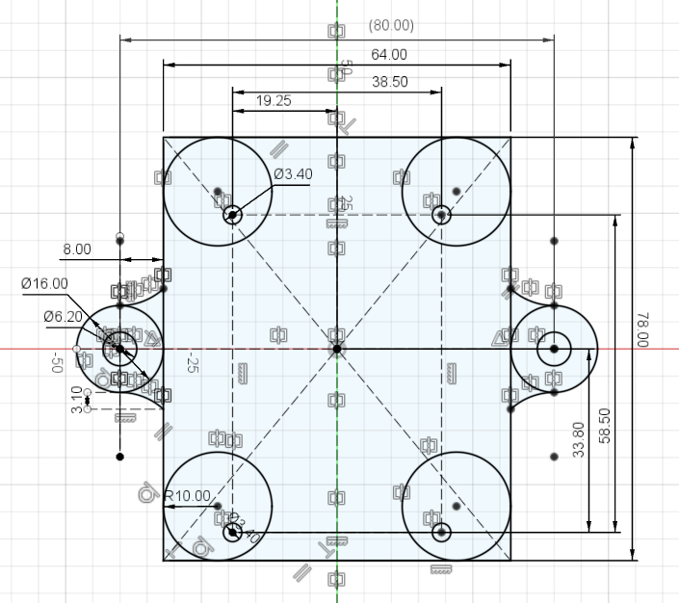

Support Beam
Total length: 288,40 mm
Camera distance: 96,20 mm
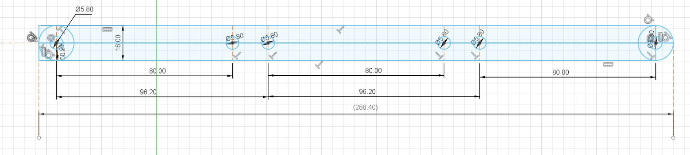

Printing layout

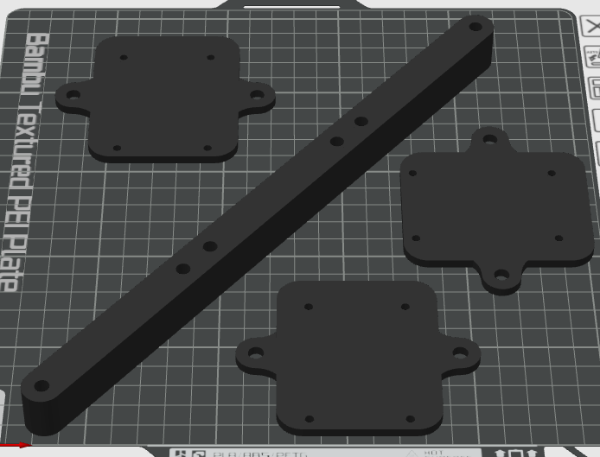

Final result (2.0)
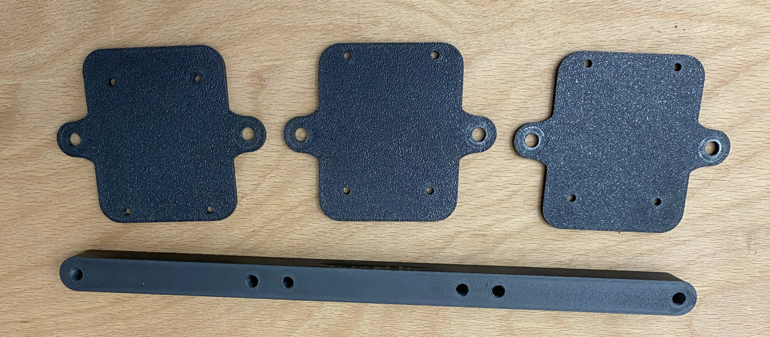
Camera plate mounted to the camera
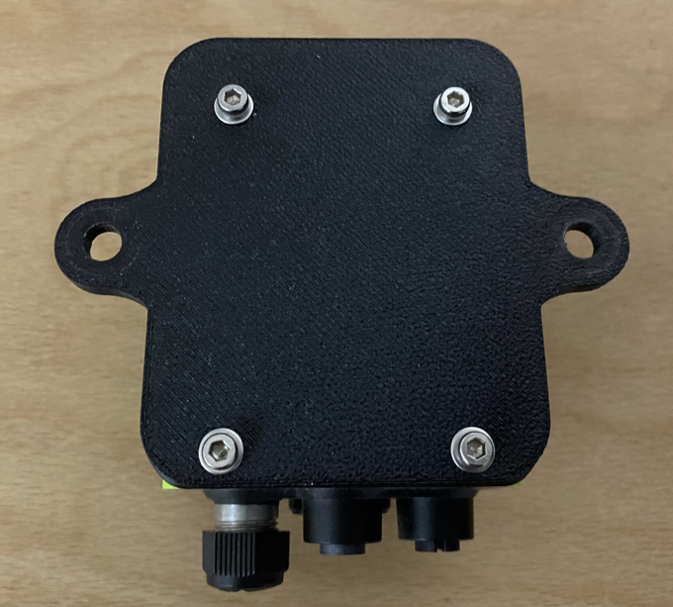
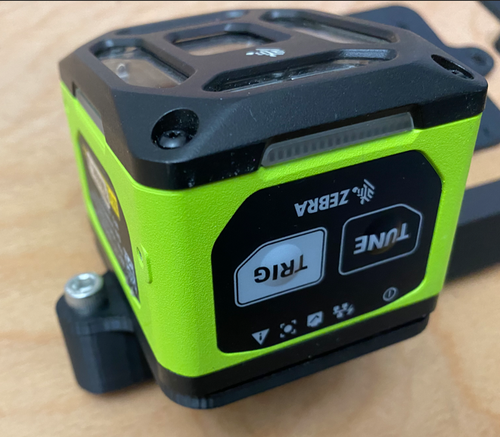 | 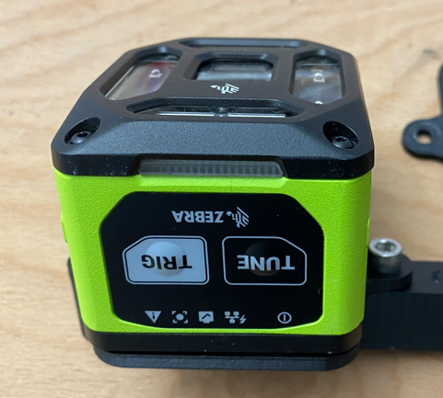

Possible improvements
The rounding diameter is not ok, better try with a lower radius (current radius is 10 mm)
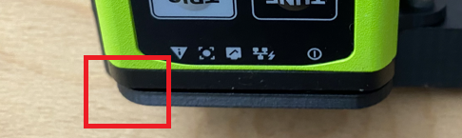

Multi Camera mount 1.0 (3 cameras 1 Clamp)

Support Beam
2 x 6 mm screws for each camera → 6 Screws
2 x 6mm washers for each camera → 6 Washers
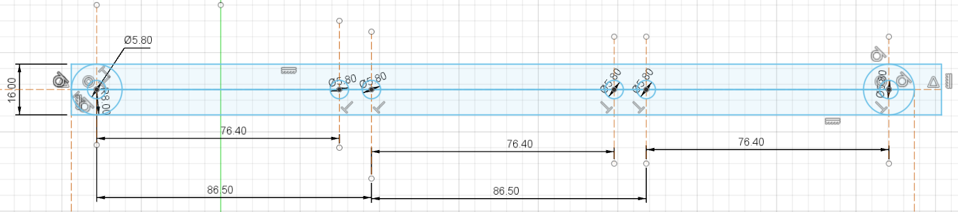

Camera Plate
Thickness: 4 mm
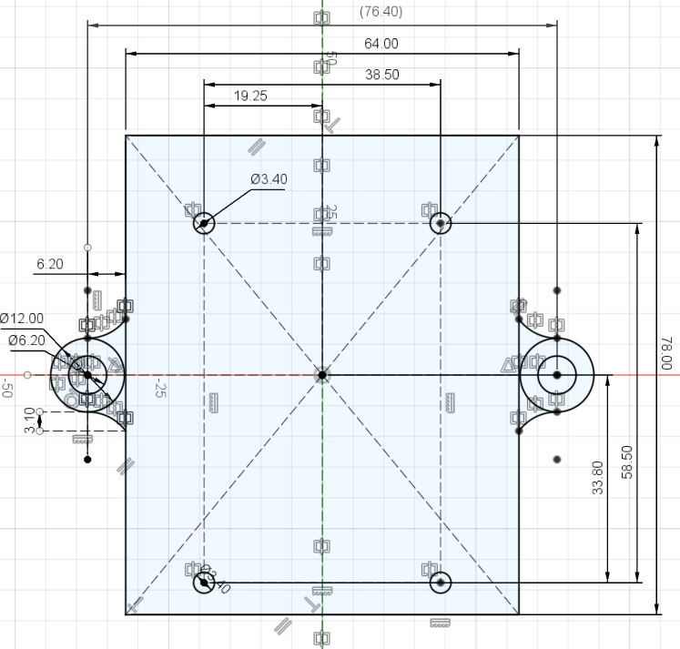

Top view

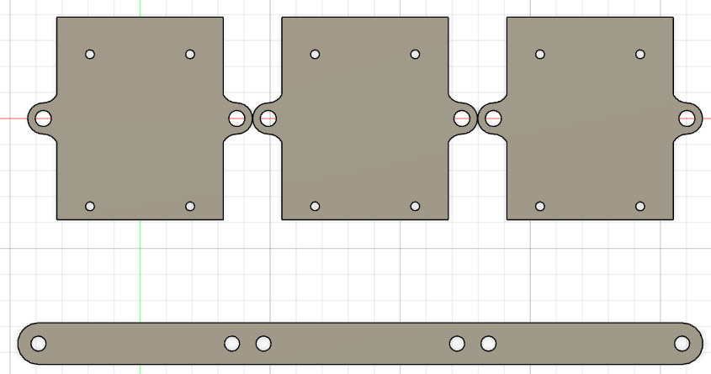

Final result
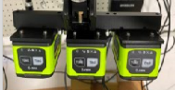 | 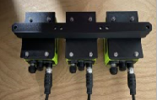 | 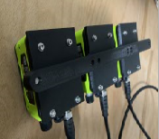

Possible improvements

Camera mount
Since the camera is rounded, so should be the camera mount. Having it squared makes it ugly
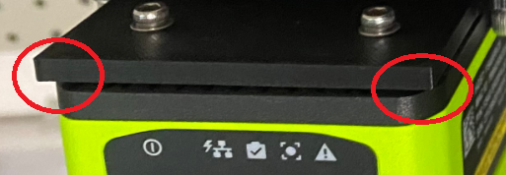

Beam and camera mount joint
The beam is 16 mm wide, the mounting fixture is 12 mm wide, hence this give an impression of mismatching
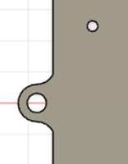 | 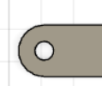 | 